The Fragile Object

The fragile object takes inspiration from the Virtual Egg objects designed by Controzzi 2017. The fragile object is composed by a box, with inside a fragile fuse and a weight of 320 gr.

The elements that compose the fragile object are:
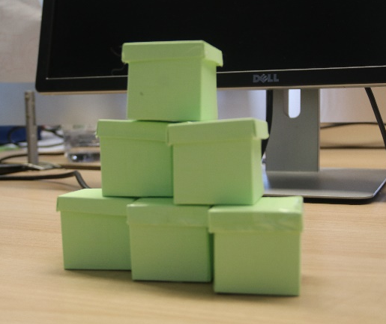
- A paper box of 50x50 mm, as container
- A fuse (in this case is a piece of spaghetto), placed in the middle of the box
- A support for the fuse (the black piece in the picture)
- Lead weight for a total amount of 320 gr, placed in the bottom

Assembly Instruction
Necessary material:
- Paper box 50x50 mm, with its cover
- Support for the fuse
- Piece of spaghetto, length 50 mm
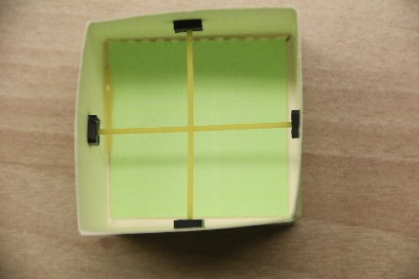
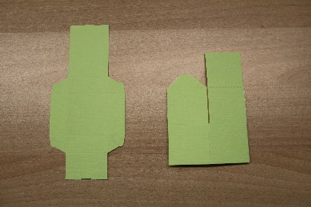
Figure 1 Paper box with its fuse

Figure 3 Piece of spaghetto
Figure 2 Support for the fuse

Following the instruction to assemble the virtual egg:
- 3D printed the support (you can find the file Cad in Technical documents, in the webpage).
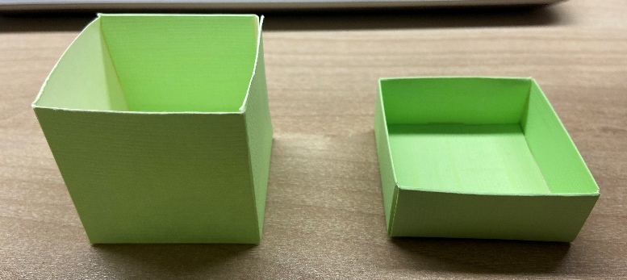
- Assemble the paper box and cover

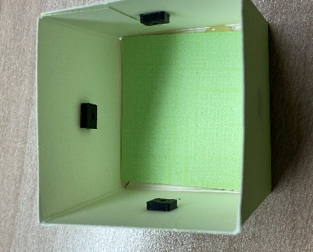
- Identify the center of two parallel side of the box and fix the support with glue.
- Insert the lead weight on the bottom of the box
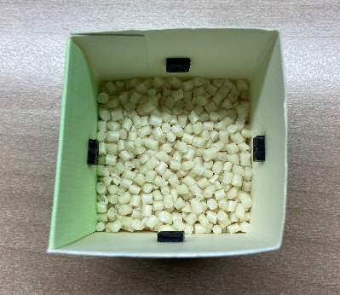
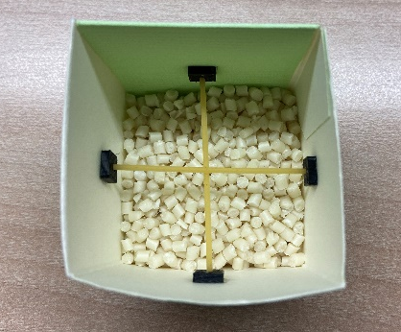
- Place the fuse in the support

- Close the box with its cover

Controzzi, M., Clemente, F., Pierotti, N., Bacchereti, M., Cipriani, C., & Superiore, S. (2017). Evaluation of hand function trasporting fragile objects: the virtual eggs test. In Myoelectric Control Symposium. New Brunswick, CA: University of Salford.

